TOWN OF STAFFORD SPRING
NEWSLETTER 2024

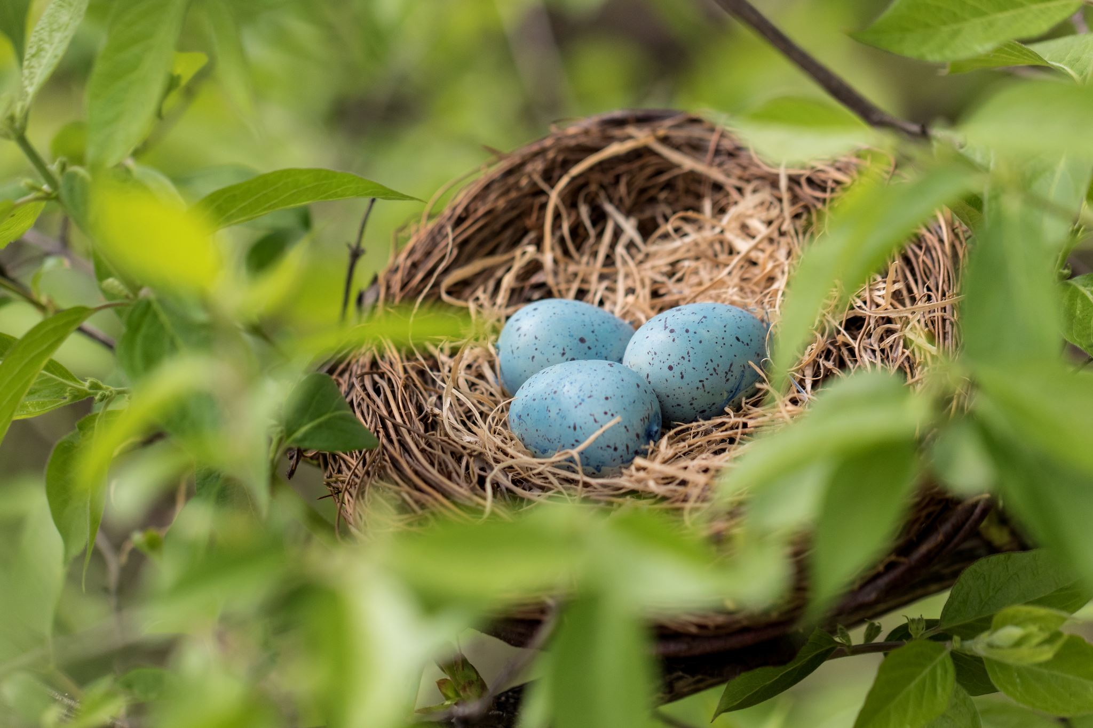

TOWN OF STAFFORD GOVERNMENT
TOWN SUPERVISOR TOWN CLERK/TAX COLLECTOR BOARD OF ASSESSMENT REVIEW
Robert Clement Barbara Radley David Kent
rclement@rochester.rr.com townclerk@townofstafford.org Carol Queal
(585) 344-0672 (585) 344-1554 Ext. 104 John Muehlbauer
TOWN COUNCILMAN DEPUTY CLERK ASSESSOR
Robert Pacer Jane Scott Lori Frongetta
RbtPacer@gmail.com Assessor@townofstafford.org
(585) 507-6856 ZONING BOARD (585) 344-1554 Ext. 106
Terry Young Michael Lathan TOWN HISTORIAN
Tyoung14143@gmail.com Jackie Ali Colleen O’Connor
(585) 409-1804 Crista Boldt (585) 344-1554 Ext. 108
James Duyssen Leslie Krajewski
Jaduyssen@gmail.com Tim Thomas-Alt.
(585) 993-4088 Walt Kershenski-Secretary
Ronald Panek PLANNING BOARD POST OFFICE
RndPanek@gmail.com William VanAlst Hours: Monday – Friday
(585) 815-9321 Sharon Valyear-Gray 9:45-1:45, 2:45-4:45
Carol Queal Saturday
Lindsay Yoder 10:00-12:00
Anita Taylor
Paul Tenney
Richard Squires
Lucas Torrey-Alt
Walt Kershenski-Secretary

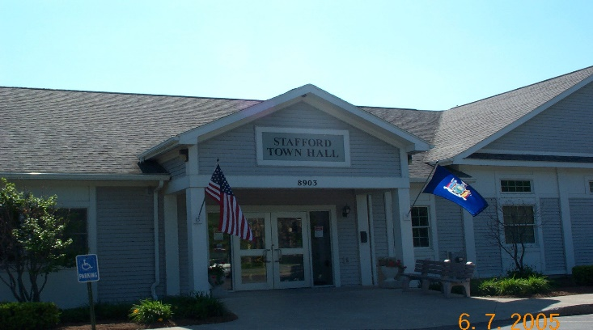

A NOTE FROM OUR SUPERVISOR
Hello and Happy Spring to all. This has been a very busy Town lately. First, I would like to congratulate Terry Young on his election to the Town Board; I am confident that Terry will be an asset to our Town.
Water District 12 is well underway, and we are very happy for the progress in the last few months. There is work being done to investigate the possibility of town-wide water, please stay tuned for that information.

TOWN CLERK NEWS
The Town Clerk’s office is a very busy place with the DEC licenses we issued this past fall. Take note that the state is changing the licensing program soon and will no longer have the colored paper printed, the licenses will be printed on plain paper. I am still learning about this so bear with me, please. I am also trying to update the dog licensing program and hope to have an enumerator in place to conduct an actual census of the population this summer. Again, taxes are going well, Jane and I are a good team and enjoy the work we do for you. Marriage licenses are going smoothly as well, congratulations to all the newlyweds. Please stop in any time to chat and let me know how we can serve you.

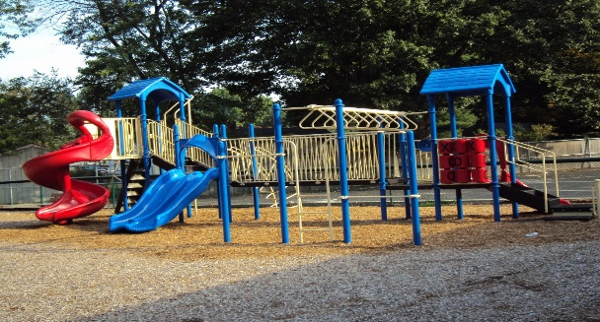
Summer Recreation News
Hello everyone!
We are in the process of planning our Summer Recreation Program.
Our program this year will run from Tuesday, June 25th until Friday August 9th.
More details to follow.
Laurie Pocock
Recreation Director

From the Assessor:
This has been a very busy time for me. Ag exemptions and Star/Enhanced Star/Limited Income Senior exemptions have kept me hopping. Now I am getting the Final Assessment Roll completed.
I enjoyed meeting all of you. Have a great summer.
Lori Frongetta
Assessor

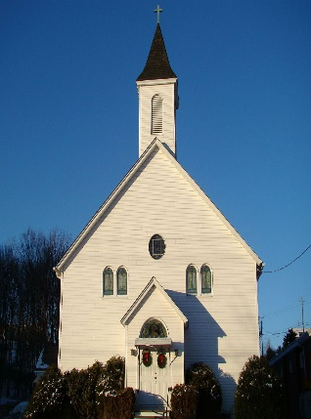Morganville United Church of Christ News
Located at 8466 Morganville Rd., Stafford, we continue to answer God’s call by serving others in the community. Along with our weekly 10:00 service, we contribute to the greater good through monthly donations of food to the LeRoy Food Pantry. During the Thanksgiving and Christmas seasons we provide food, clothing, and gifts to several needy families in the Pavilion School District. Church members come together at least once a year to offer a full course meal at minimum cost to the general public.
Our music director, Caren Wade, comes to us with many years of experience and adds music to our services that is truly inspirational. Once a year she also leads the community hymn sing that is always well attended and appreciated.
Pastor Jim Morasco has been with us over seven years and continues to offer his free spiritual counseling services to the community at large. A published author, he inspires through sermons, poetry, and a listening ear.
We’d love to meet you; maybe at our drive-thru Ham and Scalloped Potato dinner on April 13 (Presale tickets only by April 6. Call 585-757-2257 or order tickets). Friend us on Facebook! Or better yet, visit is any Sunday!

From the Stafford Methodist Church:
Church Services are on Sundays at 10:15am. Our Annual Free Giveaway is on Friday, May 31 10-4, and Saturday June 1 10-1. Clothing, kitchen and household items, toys, books… Are you in need of a location for a dinner meeting of 20 or more, contact Catherine at 409-0800 for menu and pricing.

This Photo by Unknown Author is licensed under CC BY-NC-ND
Highway News Spring 2024
This winter was a fairly light winter. Now that spring is coming winter is starting to come back for a little while. The highway department has been busy doing a street sign replacement to bring signs up to the new code that takes effect soon. Some of the road projects will be to stone and oil the Transit Road and Sweetland Road from Clipnock to Roanoke Roads. Sanders Road will have some work done on it. The School Road off Byron Road will hopefully get paved this summer. A lot of the road projects depend on the state funding from the state budget. The Highway Associations always has to lobby the Governor to get the funding that is already available from the gas tax and vehicle registrations. The Governor always threatens to cut that funding. Schools and Highway funding are the two items that will affect your local tax bills most.
The brush pile is for Stafford taxpayers. If you are planning on bringing large amounts, please let the department know. Water sales at the garage have been very busy this year with the ongoing drought conditions.

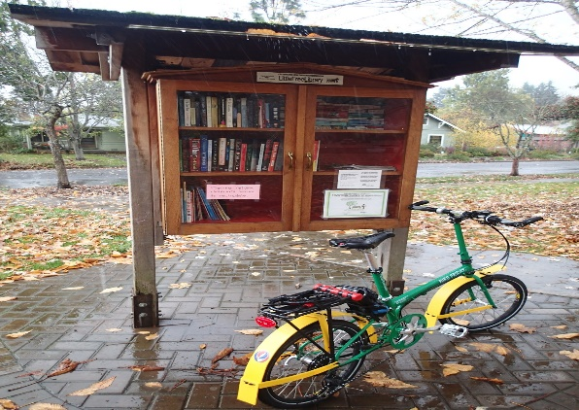St. Paul’s Episcopal Church
This Photo by Unknown Author is licensed under CC BY-SA-NC
On March 24th, St. Paul’s Church held a class for young people interested in learning to sew. Fabric, sewing machines, and supplies were provided for the participants to make simple aprons.
Our Little Library in front of the Parish Hall contains books, and non-perishable food items that are offered free to the public. Stop by and check it out.
If you are looking for a venue for an event for under 60 people, our Parish Hall is available. Contact a church member for details.
As always, Sunday services are held at 9:00 AM. All are welcome.

Stafford Garden Club
The Stafford Garden Club meets on the third Wednesday of each month beginning in March and continues through October. In June, July, and August we meet in the parking lot of the Town Hall to carpool on various garden tours. In March, April, September, and October we meet in the Town Hall to hear guest speakers on various horticultural topics. The public is welcome to attend. In May we hold our plant sale at Emery Park to raise funds for the scholarship we offer each year. As part of our community service, we will be planting flowers in containers in front of the Town Hall and also will help to maintain the gardens in Ilette Park.

Historical Society News
What is the Stafford Historical Society…it’s all about HISTORY! The Society has been around since 1982. Our “Mission is to document, preserve and present the History of the Town of Stafford and its residents…through the collections and exhibits in the Stafford Museum, which is located behind the Town Hall Building. At our monthly meetings, we learn what Stafford was and how it became what it is today.
The Historical Society has had many changes in the last three years due to the interruptions of the Covid-19 epidemic. As a result, certain adjustments will be made, especially due to the loss of our long time President, Linda Call, who is greatly missed. Getting back on-track to our Society’s purpose and goals, we will be continuing our monthly programs, our field trips, and the high point of our year, the “Taste of Stafford”.
Hope to see you at our April 24th 7:00 monthly meeting.
Respectfully,
Phyllis Darling, Treasurer

